Using the same method, the following were the findings.

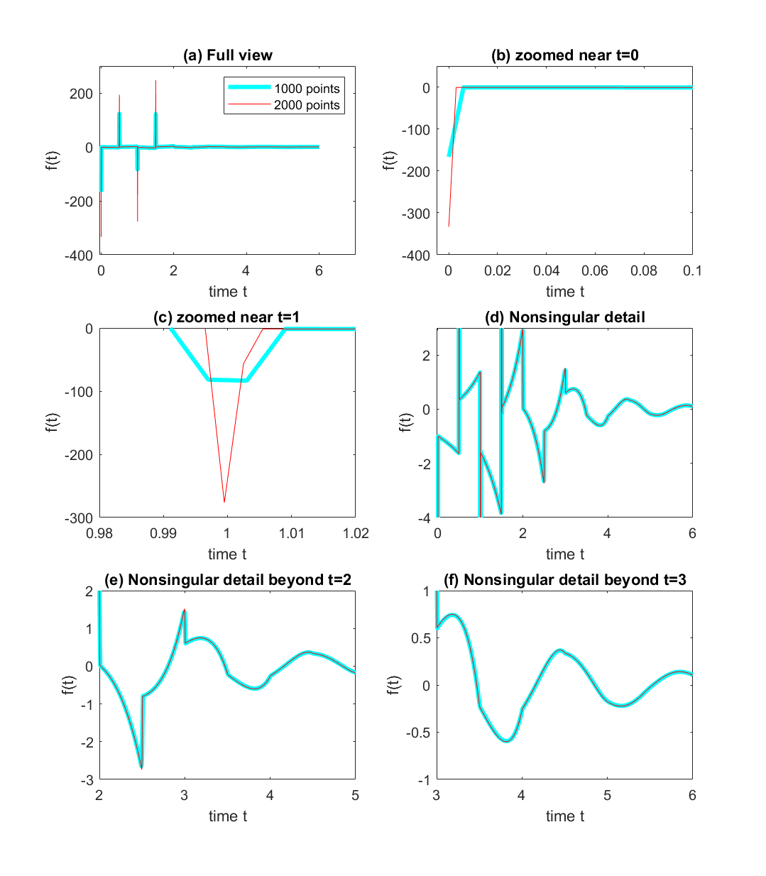

Figure 1. Values of *f(t)* for new function

From figure 1, we see Dirac Delta functions at *t= 0, .5, 1, 1.5* , and rest of the f(t) was approximated by piecewise linear polynomials on interval of .5 i.e.- (0,.5) ,(.5,1)…(5.5,6). These are plotted below

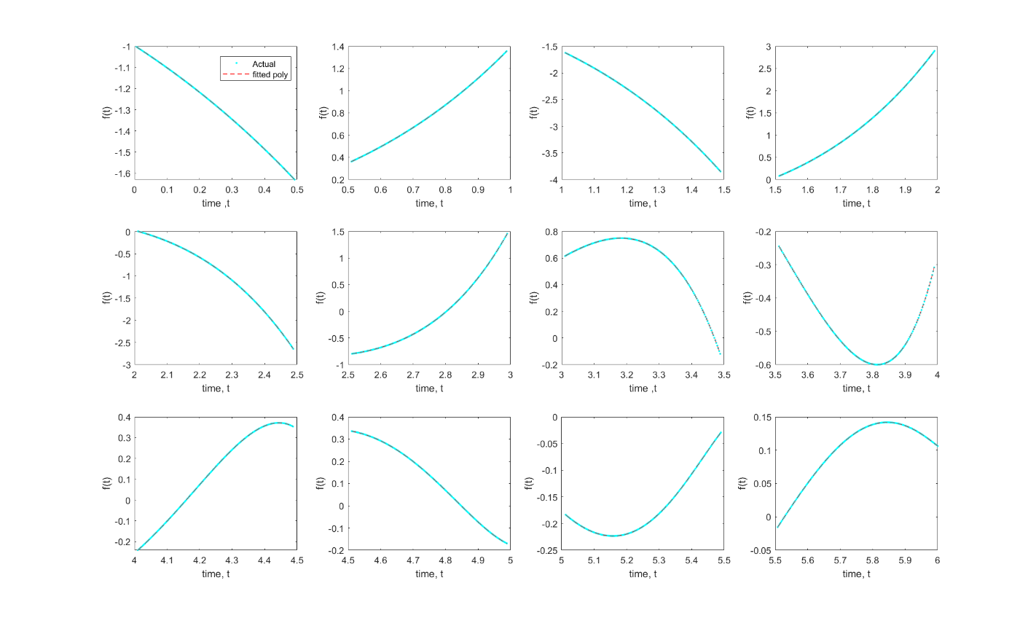

Figure 2. Piecewise polynomial approximations

So, the following new DDE is obtained, using the discrete and distributed delays.

$$\dot{x\left(t\right)}= -x\left(t\right)+x\left(t-.5\right)+-x\left(t-1\right)+x\left(t-1.5\right)+\int_{0}^{.5}{p_{1}\left(τ\right)x\left(t-τ\right) dτ}+…+\int_{5.5}^{6}{p_{12}\left(τ\right)x\left(t-τ\right) dτ}$$ The roots of the characteristic equation formed when substituting x(t)=eλt, are shown in figure 3, along with the roots found while approximating the hockey stick function.

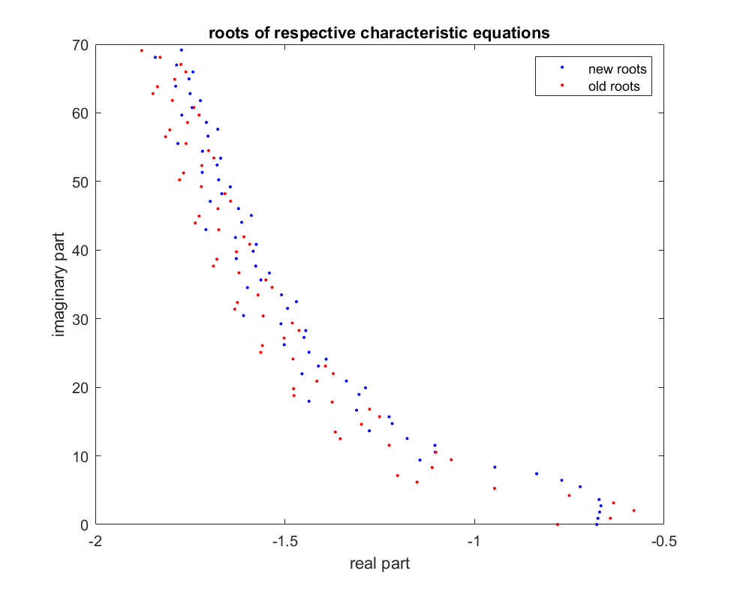

Figure 3. Roots of characteristic eq.

The following figure represent the approximations using the old basis (red colored) and the new basis (blue colored). The approximations almost similar, their difference is plotted in subplot (d).

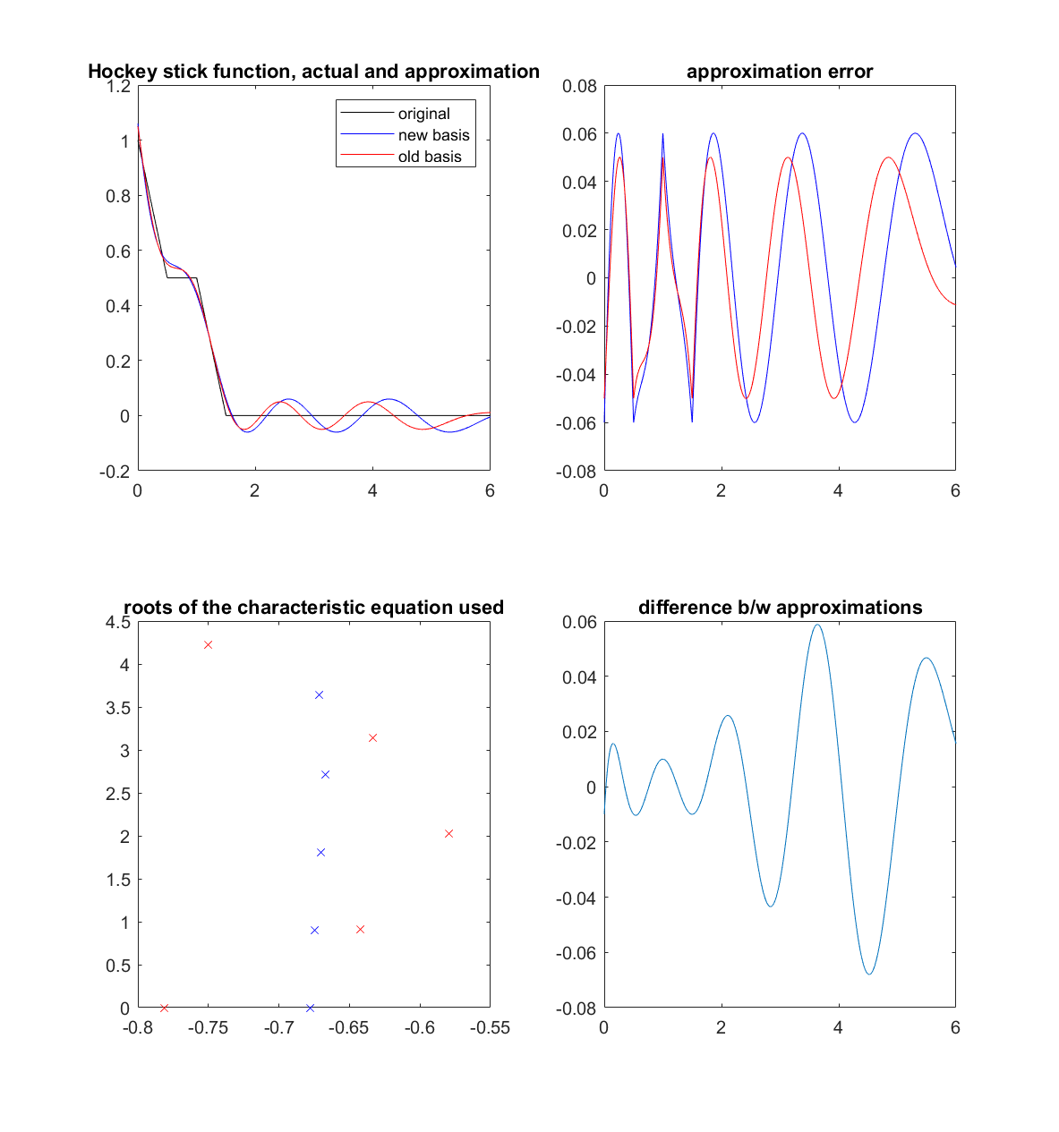

Figure 4. Approximations using 5x2 roots

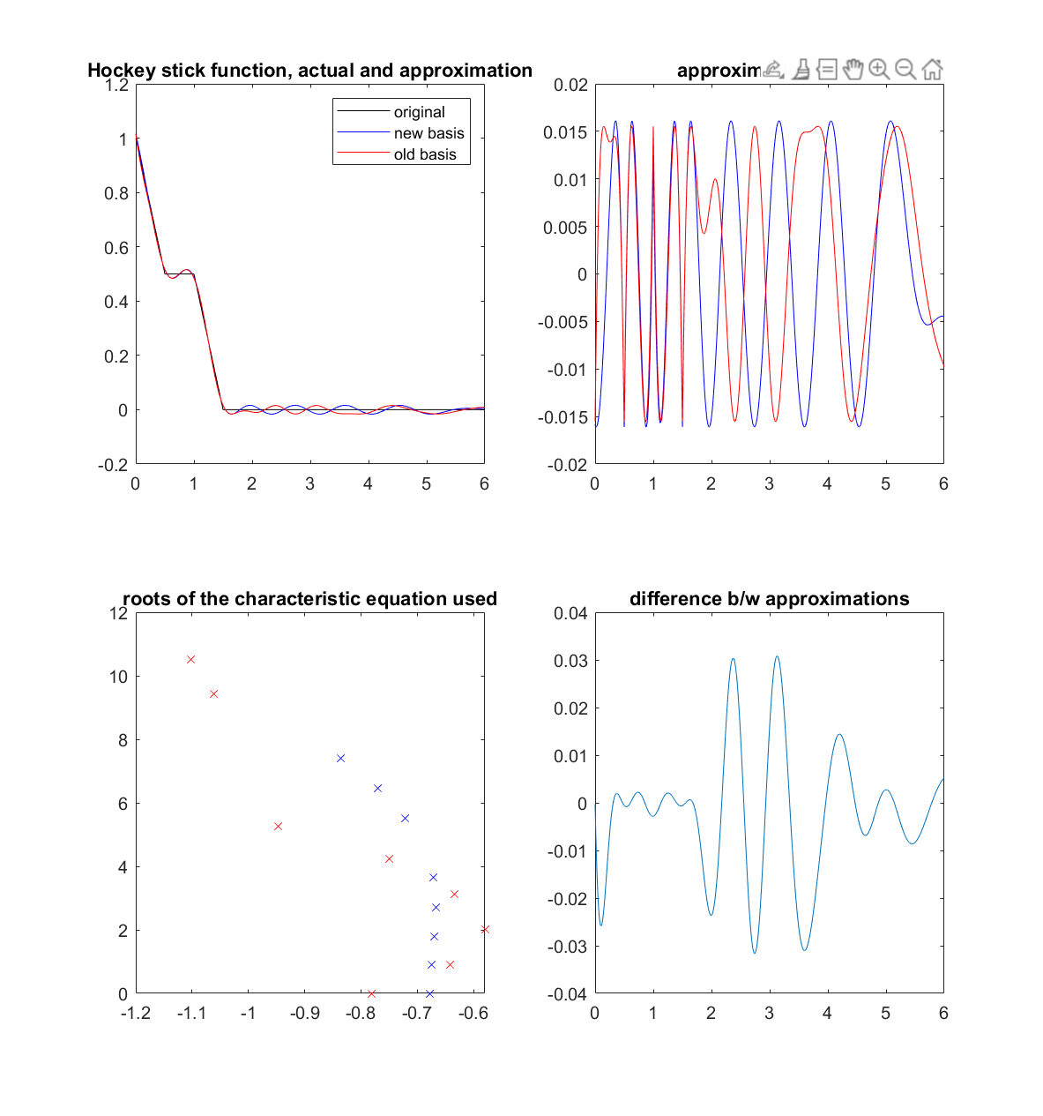

Figure 5. Approximations using 8x2 roots

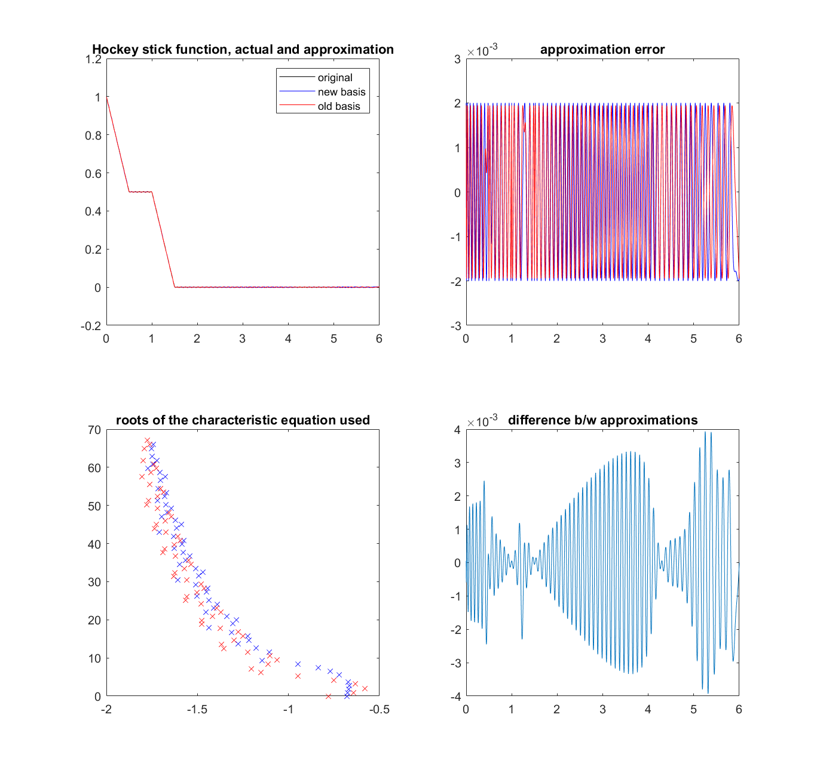

Figure 4. Approximations using 62x2 roots